**SQL Query Export Report Examples**

Key:

**Title here** *(Detail here)*

(Query Here)

**Example:**  
(Image of example query here)

**Aggregated Credential Status** *(Node Fingerprint + IP + Hostname + Asset ID + Credential Status)*

WITH max_certainty AS (

SELECT asset_id, max(certainty) AS certainty

FROM dim_asset_operating_system

GROUP BY asset_id

),

asset_cred_status AS (

SELECT DISTINCT fa.asset_id,

CASE WHEN dacs.aggregated_credential_status_id IN ('1','2') THEN 'FAIL'

WHEN dacs.aggregated_credential_status_id IN ('3','4') THEN 'SUCCESS'

ELSE 'N/A' END AS auth_status

FROM fact_asset fa

JOIN dim_aggregated_credential_status dacs ON (fa.aggregated_credential_status_id = dacs.aggregated_credential_status_id)

)

SELECT acs.asset_id,

da.ip_address,

da.host_name,

acs.auth_status,

ROUND(mc.certainty::numeric, 2) AS certainty

FROM asset_cred_status acs

JOIN dim_asset da ON (da.asset_id = acs.asset_id)

JOIN max_certainty mc ON (mc.asset_id = da.asset_id)

**Example:**

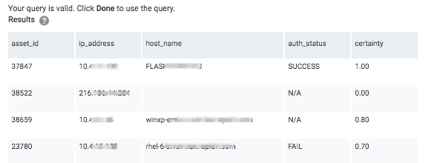

**Asset/Scan/Site + Certainty and Credential status** *(Certainty + Site Name + Credential Status + Date of last scan)*

SELECT asset_id, scan_id, date, name, credential_status_description, certainty

FROM fact_asset_scan_service

JOIN dim_credential_status USING(credential_status_id)

JOIN dim_service USING(service_id)

JOIN dim_asset_operating_system USING(asset_id)

**Example:**

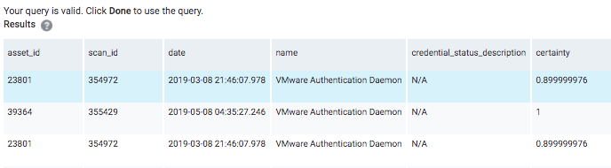

**Search for various Software** *(Site name + IP + MAC + DNS Hostname + Vendor + Software Name/Family/Class ~ This example is searching for ‘Cyber’ & ‘Crowd’ so change the second and third to last line to change the target software you are looking for)*

SELECT da.sites AS "Site_Name",

da.ip_address AS "IP_Address",

da.mac_address AS "MAC_Address",

da.host_name AS "DNS_Hostname",

ds.vendor AS "Vendor",

ds.name AS "Software_Name",

ds.family AS "Software_Family",

ds.version AS "Software_Version",

ds.software_class AS "Software_Class"

FROM dim_asset_software das

JOIN dim_software ds USING(software_id)

JOIN dim_asset da ON da.asset_id = das.asset_id

WHERE ds.name LIKE '%Cyber%'

OR ds.name LIKE '%Crowd%'

ORDER BY ds.name ASC

**Example:**

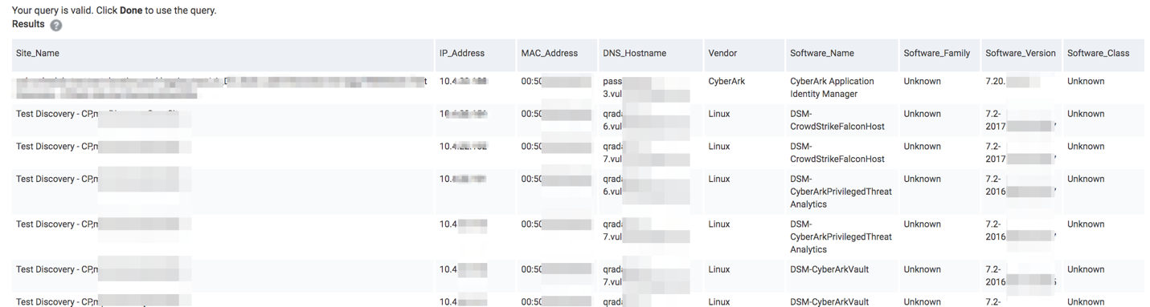

**All Dynamic Asset Groups: Count/Vulns by date/severity** *(Dynamic Asset Group + total asset count + vulnerability data from 30-60-90 days out broken down by severity + total vulnerability count in DAG)*

WITH

asset_vuln_finding_age AS (

-- List the age of vuln findings in scope, along with their asset information

SELECT avd.asset_id,

CASE WHEN (avd.age < 30 AND dv.severity_score < 4) THEN 1 ELSE 0 END AS "<30m",

CASE WHEN (avd.age < 30 AND dv.severity_score >= 4 AND dv.severity_score < 8) THEN 1 ELSE 0 END AS "<30s",

CASE WHEN (avd.age < 30 AND dv.severity_score >= 8) THEN 1 ELSE 0 END AS "<30c",

CASE WHEN (avd.age < 60 AND avd.age >= 30 AND dv.severity_score < 4) THEN 1 ELSE 0 END AS "30-60m",

CASE WHEN (avd.age < 60 AND avd.age >= 30 AND dv.severity_score >= 4 AND dv.severity_score < 8) THEN 1 ELSE 0 END AS "30-60s",

CASE WHEN (avd.age < 60 AND avd.age >= 30 AND dv.severity_score >= 8) THEN 1 ELSE 0 END AS "30-60c",

CASE WHEN (avd.age < 90 AND avd.age >= 60 AND dv.severity_score < 4) THEN 1 ELSE 0 END AS "60-90m",

CASE WHEN (avd.age < 90 AND avd.age >= 60 AND dv.severity_score >= 4 AND dv.severity_score < 8) THEN 1 ELSE 0 END AS "60-90s",

CASE WHEN (avd.age < 90 AND avd.age >= 60 AND dv.severity_score >= 8) THEN 1 ELSE 0 END AS "60-90c",

CASE WHEN (avd.age >= 90 AND dv.severity_score < 4) THEN 1 ELSE 0 END AS "90+m",

CASE WHEN (avd.age >= 90 AND dv.severity_score >= 4 AND dv.severity_score < 8) THEN 1 ELSE 0 END AS "90+s",

CASE WHEN (avd.age >= 90 AND dv.severity_score >= 8) THEN 1 ELSE 0 END AS "90+c"

FROM (

-- Find earliest finding date for a vuln, coupled with the most recent instance count for the vuln

SELECT fasv.asset_id, fasv.vulnerability_id, date_part('days', (CURRENT_DATE - MIN (fasv.date)) + interval '1 day') AS age

FROM fact_asset_scan_vulnerability_instance fasv

-- Filter to only include vuln findings present in the latest scan

JOIN fact_asset_vulnerability_instance fav ON fasv.asset_id = fav.asset_id

AND fasv.vulnerability_id = fav.vulnerability_id

AND fasv.service_id = fav.service_id

AND fasv.port = fav.port

AND fasv.proof = fav.proof

GROUP BY fasv.asset_id, fasv.vulnerability_id

) avd

JOIN dim_vulnerability dv ON dv.vulnerability_id = avd.vulnerability_id

)

SELECT *

FROM (

SELECT dag.name AS group_name,

COUNT(DISTINCT vfa.asset_id) AS asset_count,

SUM(vfa."<30m") AS "<30_moderate",

SUM(vfa."<30s") AS "<30_severe",

SUM(vfa."<30c") AS "<30_critical",

SUM(vfa."30-60m") AS "30-60_moderate",

SUM(vfa."30-60s") AS "30-60_severe",

SUM(vfa."30-60c") AS "30-60_critical",

SUM(vfa."60-90m") AS "60-90_moderate",

SUM(vfa."60-90s") AS "60-90_severe",

SUM(vfa."60-90c") AS "60-90_critical",

SUM(vfa."90+m") AS "90+_moderate",

SUM(vfa."90+s") AS "90+_severe",

SUM(vfa."90+c") AS "90+_critical",

SUM(vfa."<30m") + SUM(vfa."<30s")+ SUM(vfa."<30c") + SUM(vfa."30-60m")+ SUM(vfa."30-60s") + SUM(vfa."30-60c") +

SUM(vfa."60-90m") + SUM(vfa."60-90s") + SUM(vfa."60-90c") + SUM(vfa."90+m") + SUM(vfa."90+s") + SUM(vfa."90+c") AS vuln_count

FROM (

SELECT *

FROM asset_vuln_finding_age

UNION ALL

-- Include zero counts for assets that have no vuln findings

SELECT da.asset_id, 0 AS "<30m", 0 AS "<30s", 0 AS "<30c", 0 AS "30-60m", 0 AS "30-60s", 0 AS "30-60c",

0 AS "60-90m", 0 AS "60-90s", 0 AS "90+m", 0 AS "60-90c", 0 AS "90+s", 0 AS "90+c"

FROM dim_asset da

WHERE asset_id NOT IN (SELECT DISTINCT asset_id FROM asset_vuln_finding_age)

) vfa

JOIN dim_asset_group_asset daga ON daga.asset_id = vfa.asset_id

JOIN dim_scope_asset_group USING (asset_group_id)

JOIN dim_asset_group dag USING (asset_group_id)

GROUP BY dag.name

) site_vuln_counts

UNION ALL

-- Include zero counts for asset groups in scope with no assets

SELECT dag.name AS group_name, 0 AS asset_count, 0 AS "<30m", 0 AS "<30s", 0 AS "<30c", 0 AS "30-60m", 0 AS "30-60s", 0 AS "30-60c",

0 AS "60-90m", 0 AS "60-90s", 0 AS "90+m", 0 AS "60-90c", 0 AS "90+s", 0 AS "90+c", 0 AS vuln_count

FROM dim_scope_asset_group dsag

JOIN dim_asset_group dag USING(asset_group_id)

WHERE dsag.asset_group_id NOT IN (

SELECT DISTINCT daga.asset_group_id

FROM dim_asset da

JOIN dim_asset_group_asset daga USING(asset_id)

)

ORDER BY group_name

**Example:**  
